1. **What are the benefits of using CSS?**

**Ans**.

* **Separation of Content and Design:** CSS allows the separation of content from design. This means you can define the look and feel of a website separately from its structure and content.
* **Easy Maintenance:** With CSS, you can make changes to the design of a website by altering the CSS file, rather than editing each individual web page.

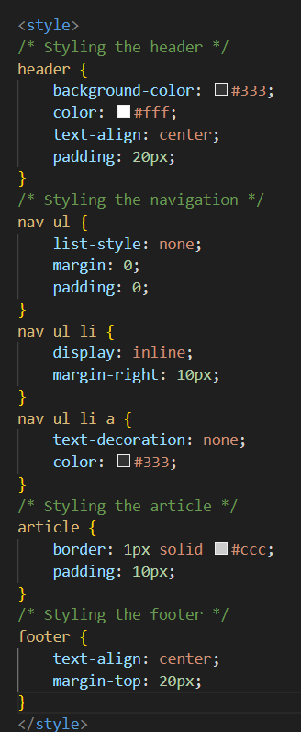**Example:**-

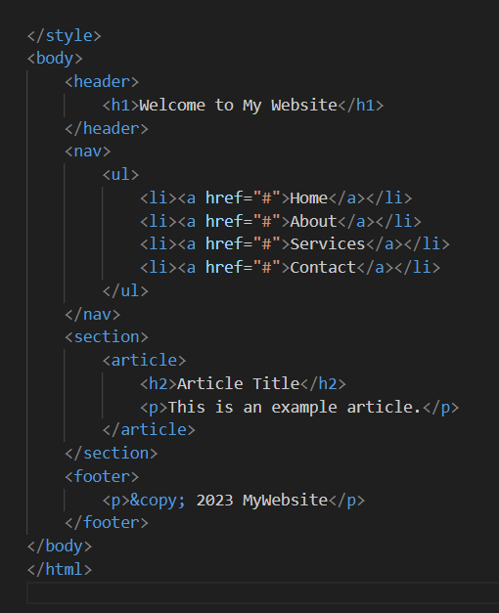

1. **What are the disadvantages of CSS?**

* **Browser Compatibility:** Different browsers may interpret CSS rules slightly differently, leading to inconsistencies in how a website appears. For instance, a CSS property might render perfectly in one browser but not in another. This inconsistency can lead to extra effort in making a website compatible across multiple browsers.
* **Complexity in Large Projects:** Managing CSS for large-scale projects can become complex. As the codebase grows, organizing styles, avoiding conflicts, and maintaining a consistent design can become challenging. For instance, a global style change intended for one part of a site might unintentionally affect other areas, leading to unexpected behavior.

1. **What is the difference between CSS2 and CSS3?**

**Ans.** **Selectors:**

* **CSS2:** CSS2 introduced basic selectors like element, class, ID, attribute, and descendant selectors.
* **CSS3:** CSS3 expanded the selector capabilities with more advanced selectors such as the **nth-child** and **nth-of-type** selectors.

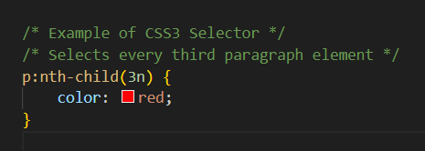

**Media Queries:**

* **CSS2:** CSS2 provided basic media types like screen, print, handheld.
* **CSS3:** CSS3 introduced media queries that allow responsive design by specifying different styles based on device characteristics like screen size, orientation, resolution, etc.

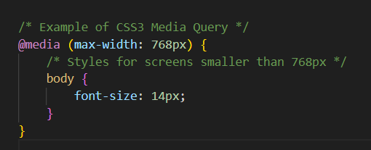

1. **Name a few CSS style components.**

**Ans** :-  **1. Text & style:-**

* + **Font:** Involves properties for defining the font style, size, weight, and family.
  + **Text:** Includes properties for styling text, such as alignment, decoration, spacing, and shadow.
  + 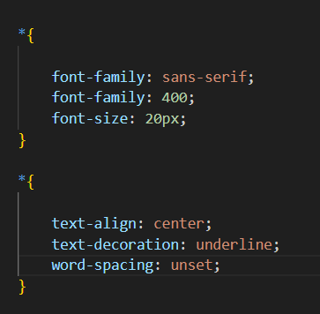

**2. Color and Background:-**

* + **Color:** Allows setting text and background colors.
  + **Background:** Properties for setting background images, colors, and positioning.

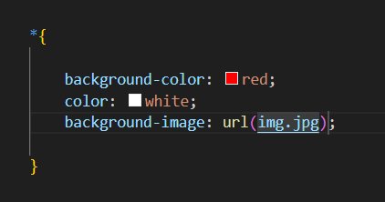

1. **What do you understand by CSS opacity?**

**Ans**:- CSS opacity is a property that controls the transparency of an element, allowing you to make it partially see-through. The opacity property takes a value from 0 to 1, where 0 is completely transparent, and 1 is fully opaque.

Example:-

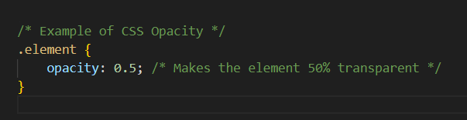

1. **How can the background color of an element be changed?**

**Ans:-** The background color of an element in CSS can be changed using the background-color property.

Example:-

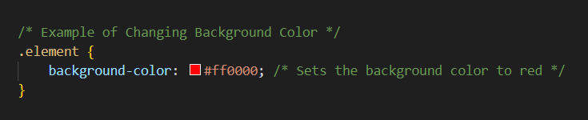

Examples using different color notations:

Using RGB:

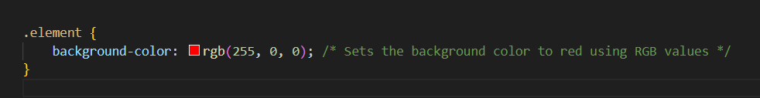

1. **How can image repetition of the backup be controlled?**

**Ans**:-In CSS, you can control how an image is repeated as a background using the **background-repeat** property. This property allows you to specify whether the background image should repeat in different directions or not repeat at all.

* **repeat-x**: The background image will repeat only horizontally.
* **repeat-y**: The background image will repeat only vertically.
* **no-repeat**: The background image will not repeat.

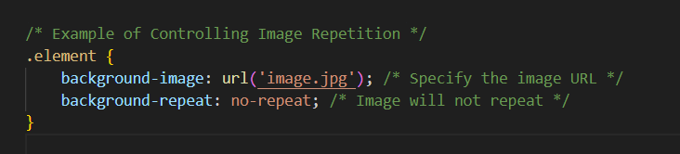

1. **What is the use of the background-position property?**

**Ans**:-The **background-position** property in CSS is used to control the initial position of a background image within its containing element.

* The property can take various values, including keywords like **top**, **bottom**, **left**, **right**, or specific length measurements and percentages.

Example:- 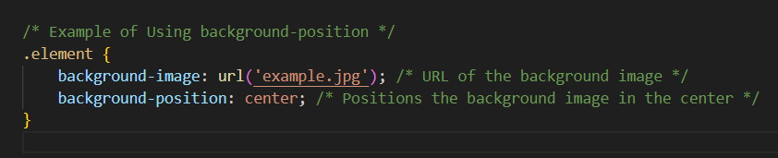

1. **Which property controls the image scroll in the background?**

**Ans:-** The property that controls how a background image scrolls within an element is background-attachment. This property determines whether the background image scrolls with the content or remains fixed within the viewport as the user scrolls through the page.

The property values are:

* **scroll**: The background image scrolls along with the element's content. This is the default behavior.
* **fixed**: The background image remains fixed within the viewport and doesn't move as the content is scrolled.

**EX**:-

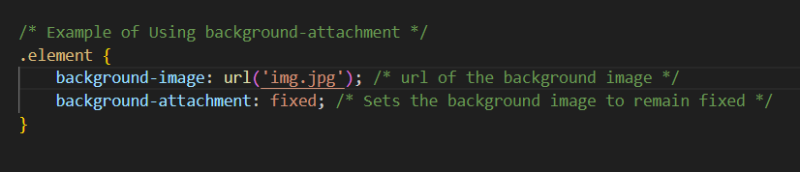

1. **Why should background and color be used as separat properties?**

**Ans:-** Separating the background and color properties in CSS allows for more granular control and better organization of styling rules. While the background property combines several background-related properties into one, using background for everything might not offer the same level of specificity or flexibility as using background and color separately.

Example:-

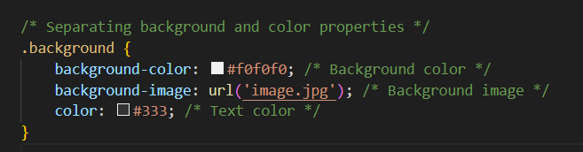

1. **How to center block elements using CSS1?**

**Ans**:- In CSS1, centering block elements horizontally or vertically wasn't as straightforward as it is in modern CSS. CSS1 didn't have dedicated properties or techniques for centering block elements.

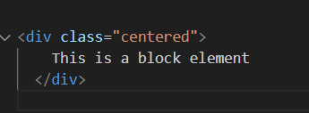

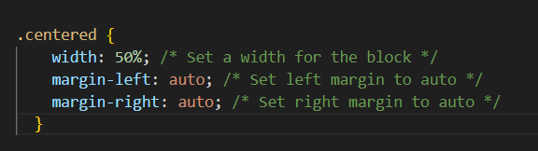

1. **How to maintain the CSS specifications?**

**Ans:-**Maintaining CSS specifications involves several best practices to ensure consistency, scalability, and ease of maintenance across your codebase.

* **Separation of Concerns:** Keep HTML, CSS, and JavaScript separate. Avoid inline styles and strive for a clean separation of structure (HTML), presentation (CSS), and behavior (JavaScript).

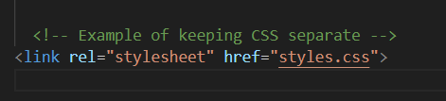

* **Consistent Naming Conventions:** Establish consistent naming conventions for classes, IDs, and other selectors. This promotes clarity and predictability in your code.

**/* Example of consistent class naming */**

**.header {}**

**.header__logo {}**

**.header__menu {}**

1. **What are the ways to integrate CSS as a web page?**

**Ans**:- The ways to integrate CSS as a web page.

1. **Inline CSS:-**

CSS can be directly included within HTML using the style attribute.

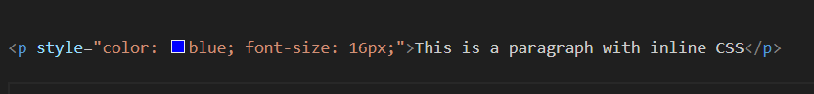

1. **Internal CSS:-**

CSS can be included within the HTML document using the <style> tag in the <head> section.

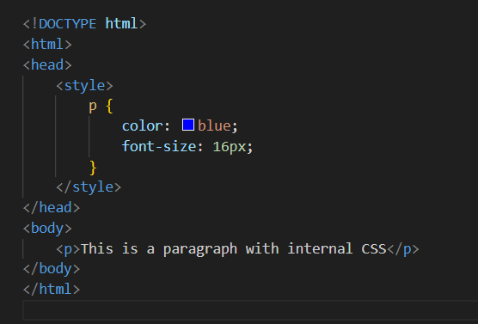

1. **External CSS:-**

CSS can be placed in an external file and linked to the HTML using the **<link>** tag in the **<head>** section.

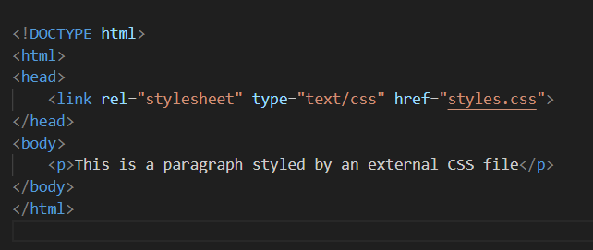

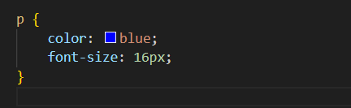

1. **What is embedded style sheets?**

**Ans:-** Embedded style sheets, also known as internal style sheets, allow you to include CSS rules directly within an HTML document's <style> tags. This method is useful for defining styles specific to that particular HTML file.

Example:- 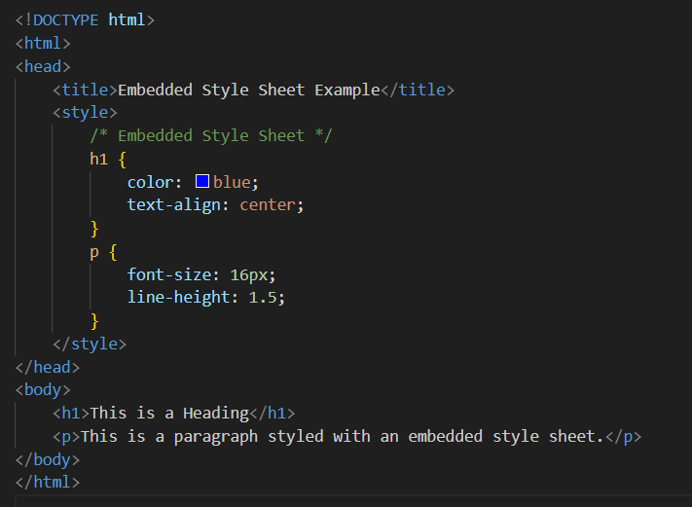

**15**. **What are the external style sheets?**

**Ans:-**External style sheets are separate CSS files containing styling rules that can be linked and applied to multiple HTML documents. They offer a more organized and maintainable way to manage styles across a website.

Example:-

Html:-

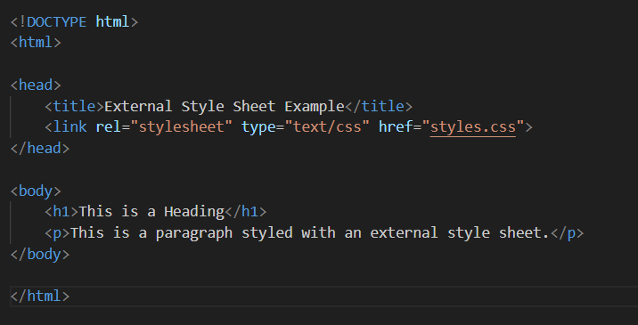

Css:-

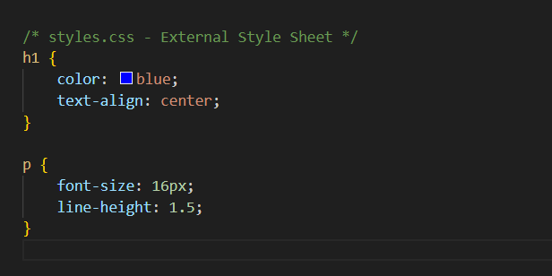

* In this example, the HTML file (index.html) links to an external CSS file (styles.css) using the <link> tag within the <head> section.

**16. What are the advantages and disadvantages of using external style sheets?**

**Ans:- Advantages:-**

* 1. **Maintainability**:- Changes made in an external style sheet are reflected across all linked HTML files. This streamlines maintenance and ensures consistent styles throughout the website.

**Example:-** If you have a website with ten pages all using the same style sheet, modifying the style sheet will instantly update the appearance of all ten pages simultaneously.

* 1. **Reusability:-** The same CSS file can be linked to multiple HTML files, promoting a consistent and reusable styling approach.

**Disadvantages:-**

1. **Dependency on Network:-** If the external style sheet fails to load due to network issues or a broken link, it can affect the rendering of the HTML content.

**Example:-**

A user on a slow network or with connectivity issues might experience a delay in loading the styles, resulting in an unstyled or poorly styled webpage.

1. **Complexity in Development:-** For small projects or when dealing with very specific styles, maintaining separate external style sheets might add unnecessary complexity.

**17. What is the meaning of the CSS selector?**

**Ans:-**CSS selectors are patterns used to select and style elements within an HTML document. They define which elements in the HTML will be affected by the styles defined in the CSS. Selectors target specific HTML elements based on their attributes, types, classes, IDs, or relationships to other elements.

**Example:-**

1. **Element Selector:-** Targets HTML elements by their tag name**.**

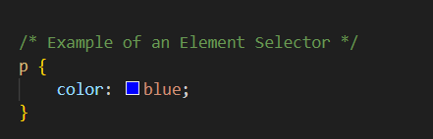

1. **Class Selector:-** Targets elements with a specific class attribute.

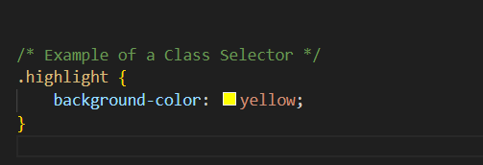

**3.ID Selector:-** Selects a specific element with a unique ID attribute.

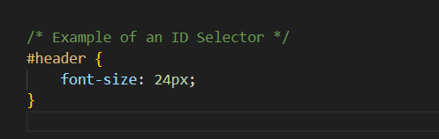

**18**. **What are the media types allowed by CSS?**

**Ans:-**CSS allows for applying styles based on different media types using the @media rule. Here are some common media types used in CSS.

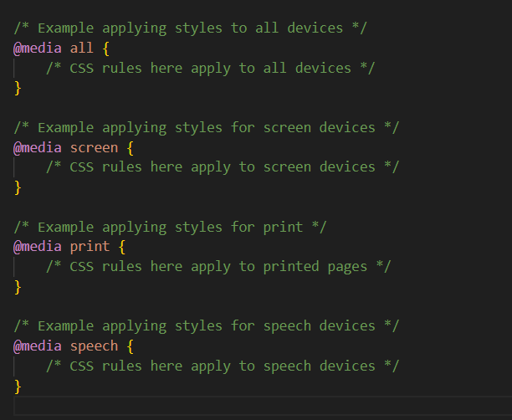

**19.** **What is the rule set?**

**Ans:- Selector: In this example, h1 is the selector. It targets all <h1> elements in the HTML document.**

* Declaration Block: The block enclosed in curly braces {} contains declarations. Each declaration includes a property and its corresponding value. For instance, color: blue;, font-size: 24px;, and text-align: center; are declarations setting the color, font size, and text alignment for the selected <h1> elements.

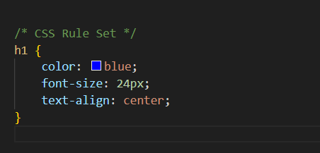

* + **Create Layouts:-**

